

User Manual
Scheduled Report Module
www.flowhcm.com

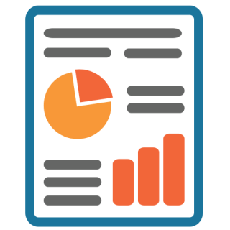

Table of Contents
Automated Report 3
STEP # 1: Report Selection 5
STEP # 2: Employee Filtration 6
STEP # 3: Report Recipients 7
STEP # 4: Report Frequency 8
STEP # 5: Data Range 10

Automated Report

- Navigate to Others Tab and click on Scheduled Report Module
- You can see the Automated Report form
- To schedule a report, click on Add Automated Report button
- The form shows Five (5) steps for input and criteria to schedule a report
- Enter the required information in the fields
- Click on save button to schedule a report

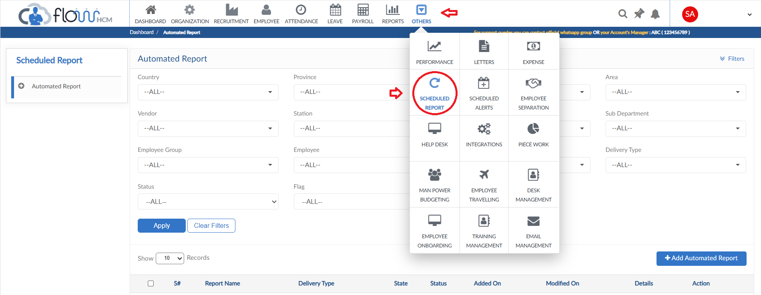
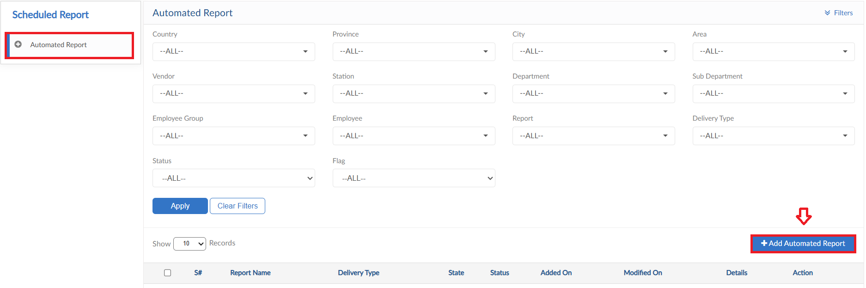
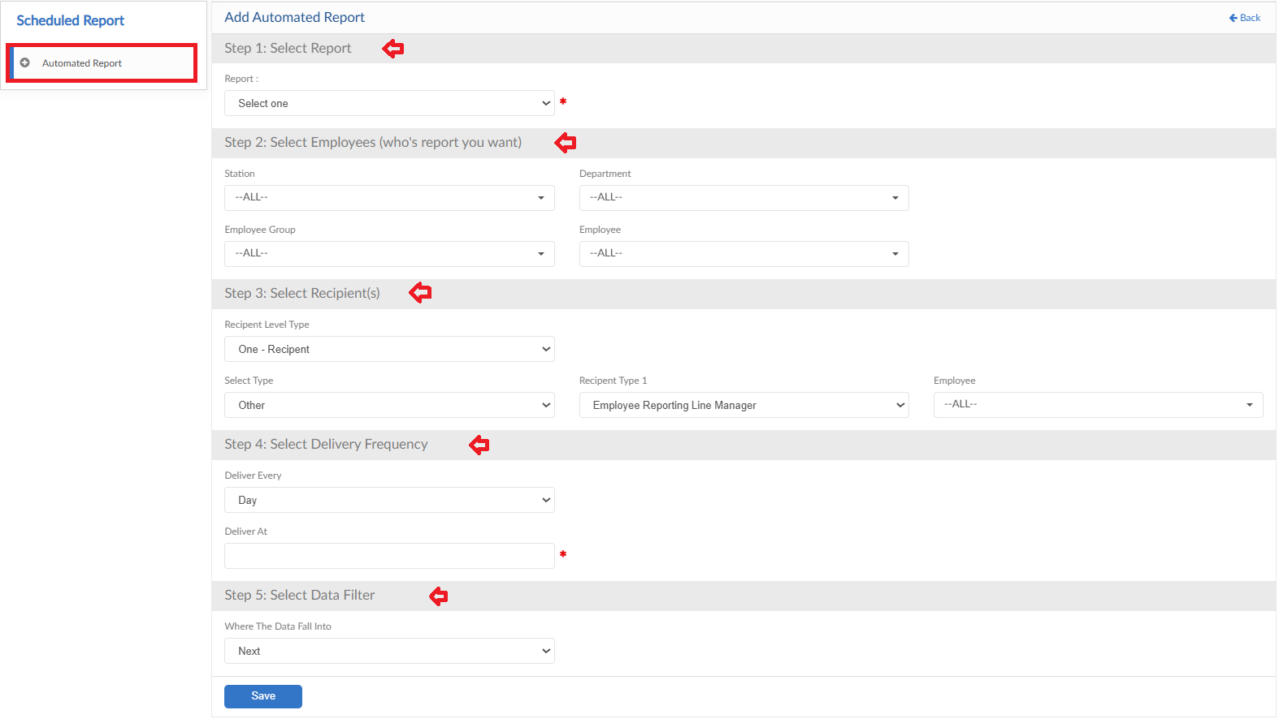

STEP # 1: Report Selection

- First step is to select the report required to schedule
- Report dropdown shows list of multiple reports
- Select any one report and move forward to the next step
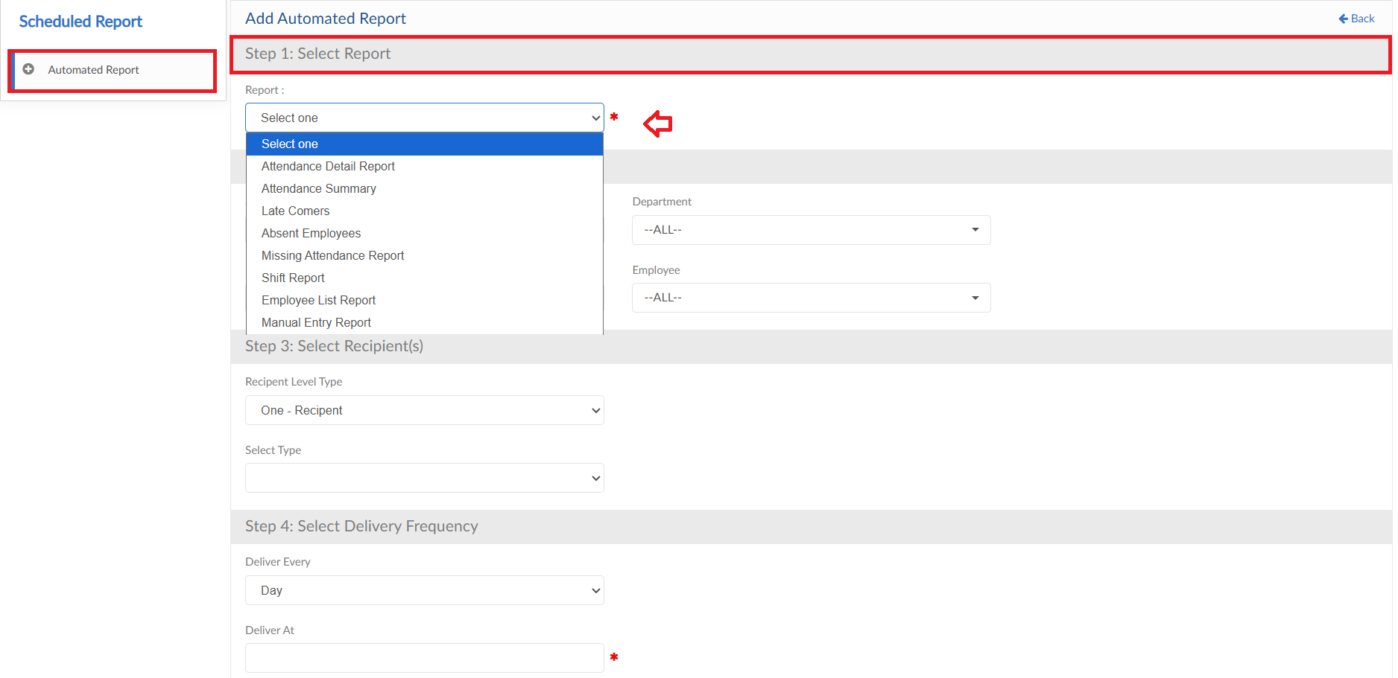

STEP # 2: Employee Filtration

- In this step, employee filter criteria will be applied whose data is required in the selected scheduled report
- Through the filters available select the required employees mapping
- Select employees from the dropdown and move forward to the next step
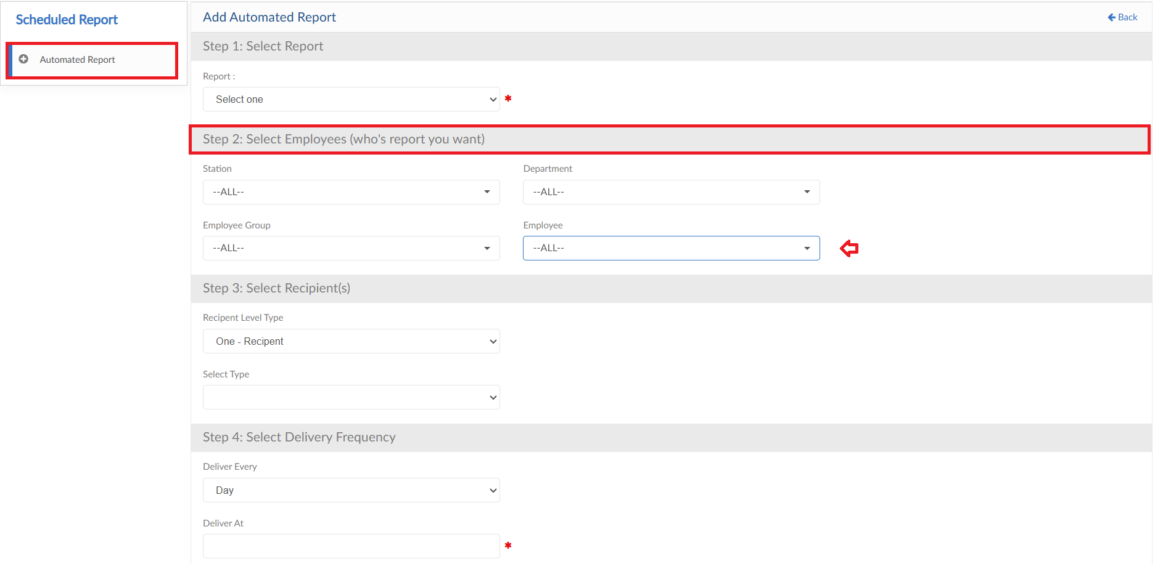

STEP # 3: Report Recipients

- In this step, recipients for report will be selected
- Select the Level and type from dropdowns
- Select Recipient type from dropdown and if required unselect employees from dropdown
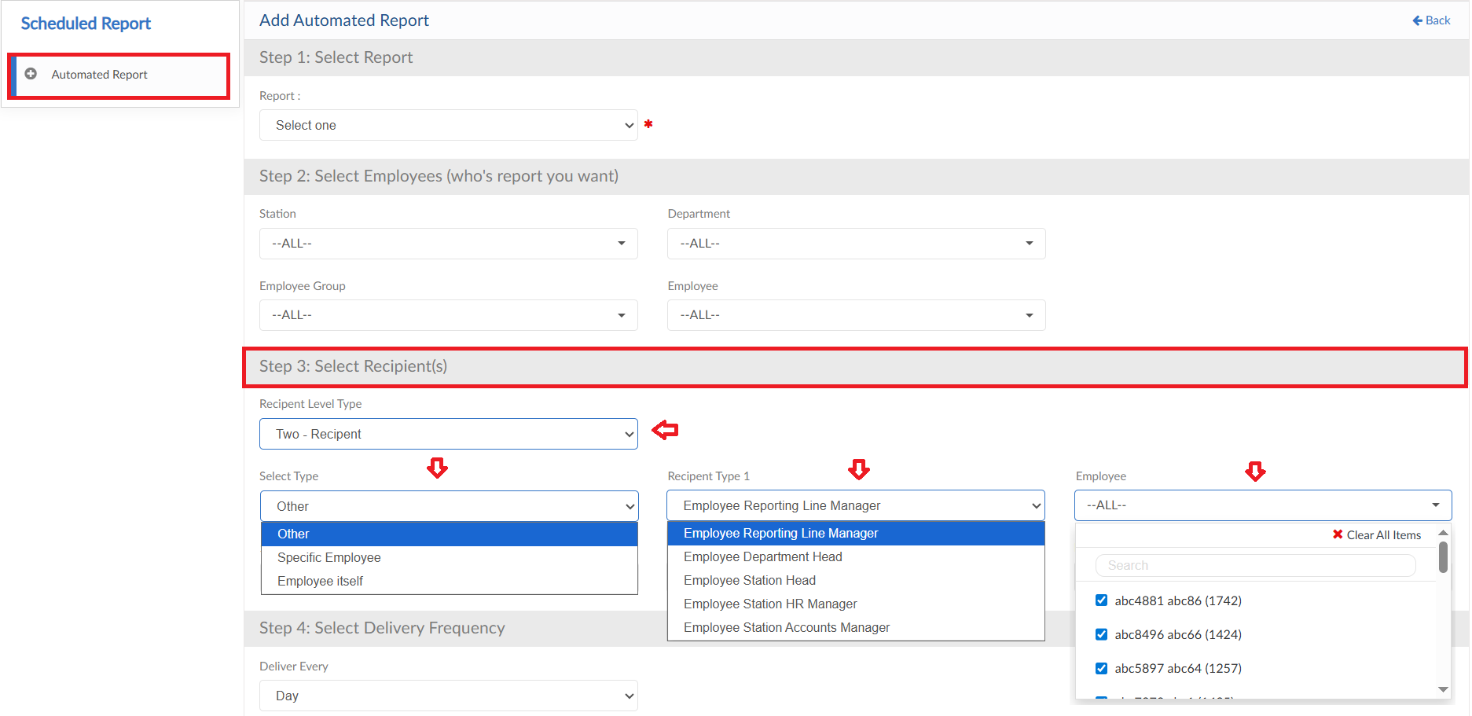

STEP # 4: Report Frequency

- In this step, report delivery frequency will be defined
- Select the frequency (Every Day/Week/Month) from dropdown and define the time to send the report
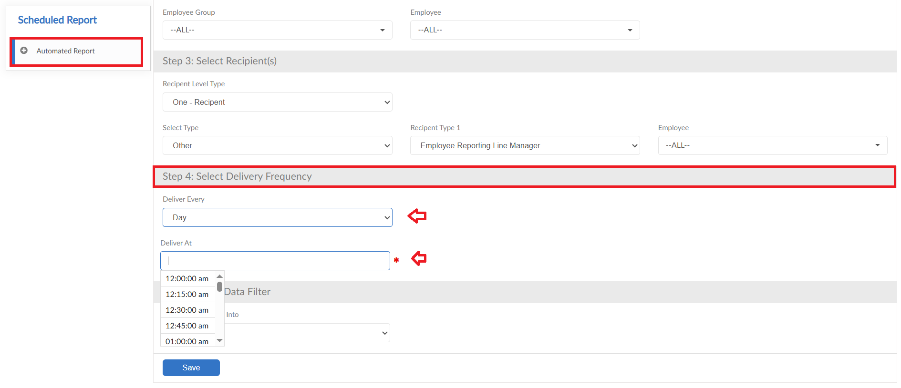
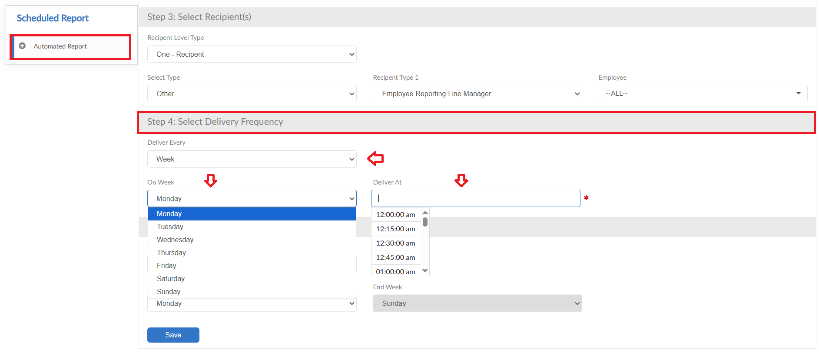
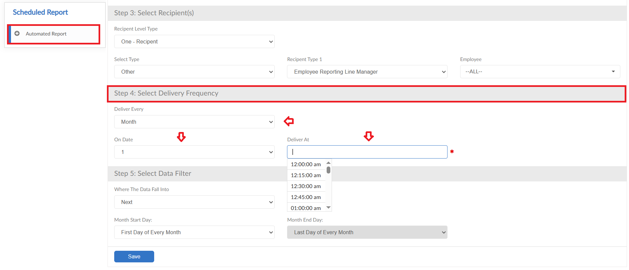

STEP # 5: Data Range

- In this step, employee data will be filtered
- Select the data range to be sent in the report
- Then click on Save button to schedule the report
